For the part A of the assignment, a simple cnn network was used, consisting of two convolutional layers and 3 fully connected layers using relu as the activation function and a softmax at the final layer. SGD was used as the optimiser and categorical crossentrophy as the loss function. Also the input was regularised by dividing by 255. In under 30 epochs, 75% accuracy on the test data was achieved.

For the part B of the assignment, 6 convolutional layers were used and a fully connected final layer. Max pooling was applied and relu was used as the activation between the layers and a softmax at the final layer. RMSPROP was used as the activation and categorical crossentrophy as the loss function. Also data augmentation was used to achieve better results. Batch size of 64 was used and a learning rate schedule was also used. The model was trained in 3 steps, each step working for 50 epochs and a final accuracy of 89.2% was achieved on the test set.

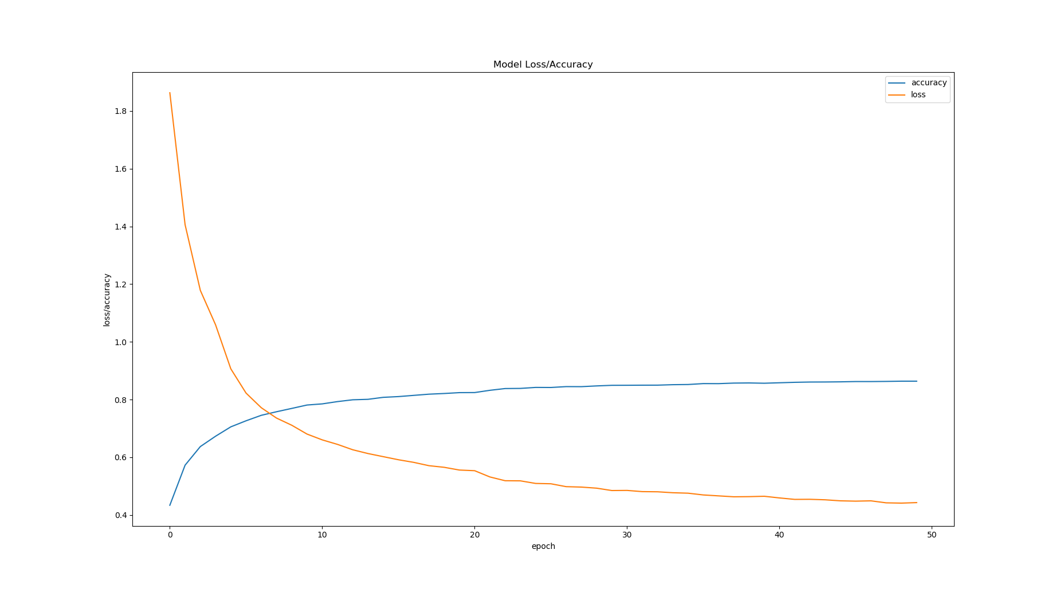The following graph was plotted from the history of the model training and each epoch took 21seconds on the local device running NVIDIA 1050 and CUDA 10.